**Documentation Human Computer Interaction (HCI) AOL**

Name: Ebenezer  
NIM: 2702226432  
Class: BY01  
Case: DiamondCut Motors

Font: Roboto

Color theme:  
Main: #222  
Secondary: #111  
BG: #ccc or #000000 with opacity 0.5 -> just means rgba(0, 0, 0, 0.5)  
Text: #fff

**FIGMA**

Link Figma: <https://www.figma.com/design/b4qaMFDcC1a7jznwbD3CNz/HCI_LAB_Aol?node-id=0-1&t=q6ECju7HxvsN78sc-1>

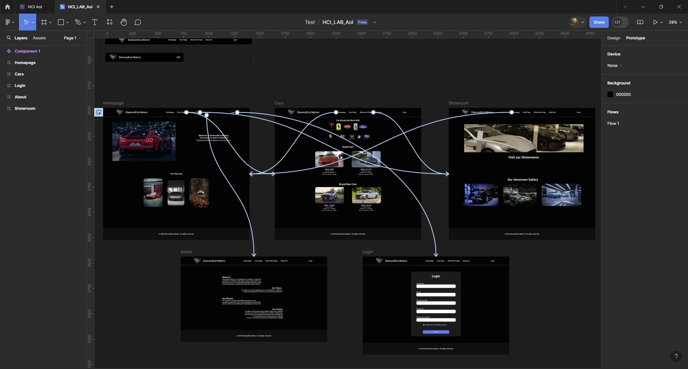

**WEBSITE**

You can open the website on [here](https://yion81.github.io/HCI_LAB/) or access the file [here](https://github.com/yion81/HCI_LAB)  
Respective links:  
<https://yion81.github.io/HCI_LAB/>  
<https://github.com/yion81/HCI_LAB>

**Website Structure:**

HTML File:

1. Index.html (homepage)
2. Cars.html
3. Showroom.html
4. About.html
5. Login.html

CSS File:

1. Styles.css (for all the html)

Javascript File:

1. homepageScripts.js
2. carsScripts.js
3. showroomScripts.js
4. loginScripts.js

**Website Criteria:**

* 1. **Home Page**

This page shows a **gallery** of the **top tier** cars and a **slider or list** of **featured cars** that are being sold in DiamondCut motors. This page also displays the company’s **tagline**.

****Page shows the company’s tagline and also a carousel video

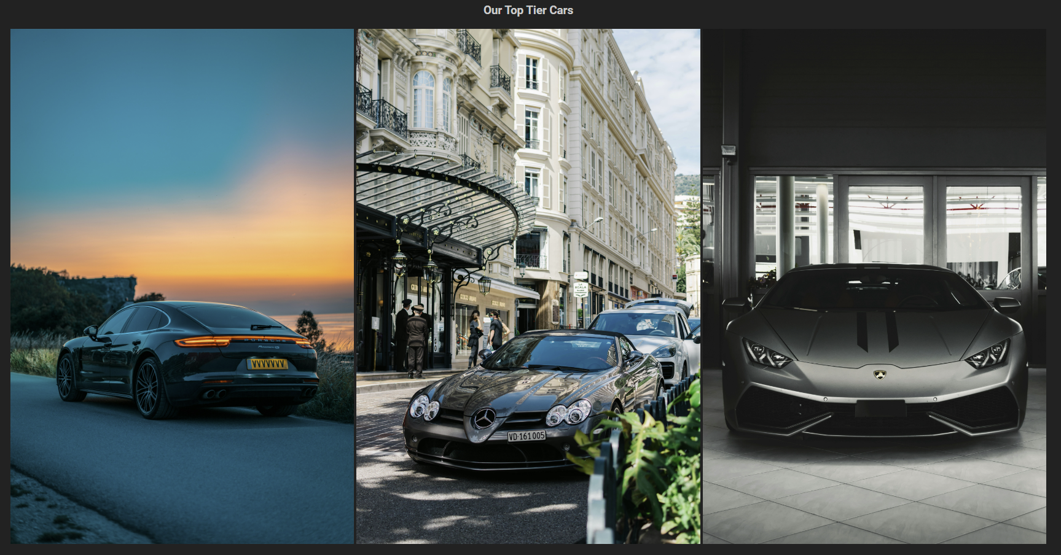

On the bottom of that we can see the gallery of carousel, 3 cars per slide.



We see footer for every page we will go through



We will also see NAV for every page we will go through. All pages are responsive.

Below is the showcase of responsiveness of homepage:

**Desktop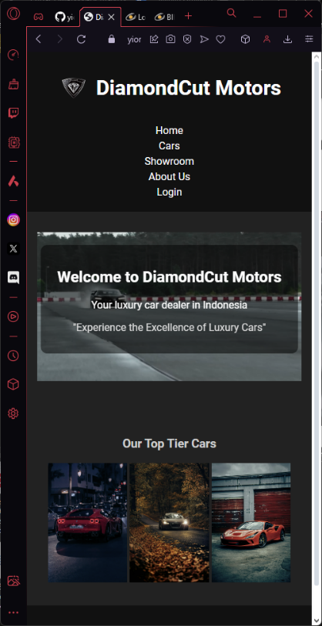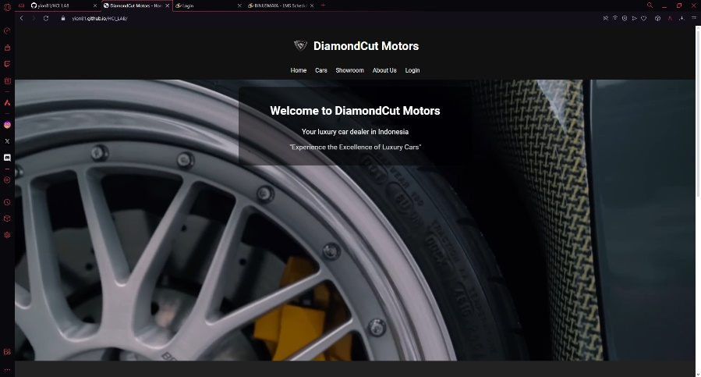Mobile (Pre-assumed)**

* **Cars Page**

This page shows a list of **used** **vehicles** and **new vehicles** that are being sold by the company. Make sure to provide the **name, brand,** and **image** of the car to provide better insights to the customers and to improve the customer’s purchasing experience. This page also displays a **carousel** of the **car brands** that are working with DiamondCut Motors.



Shows a carousel of brands we are currently working with, 5 brands per slide.

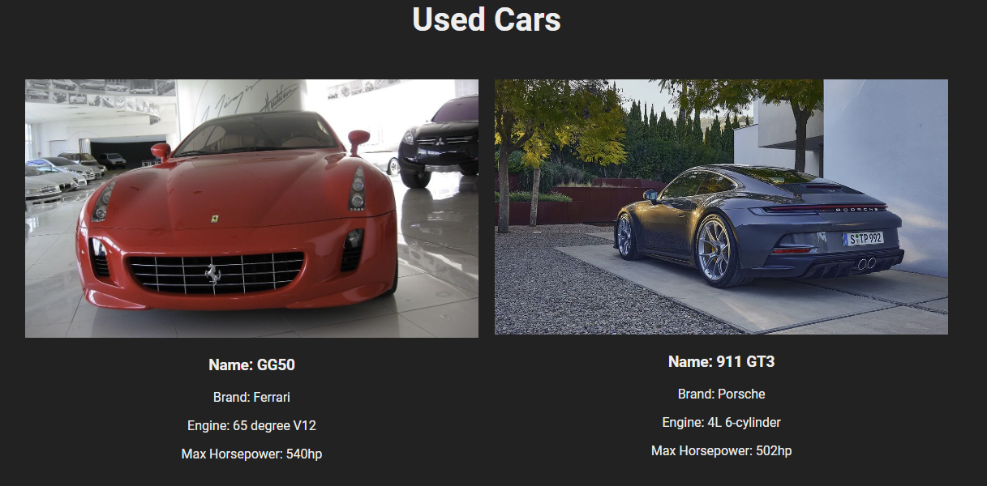

Below the brand carousel we can find a gallery-like of Used-Cars with their matching descriptions

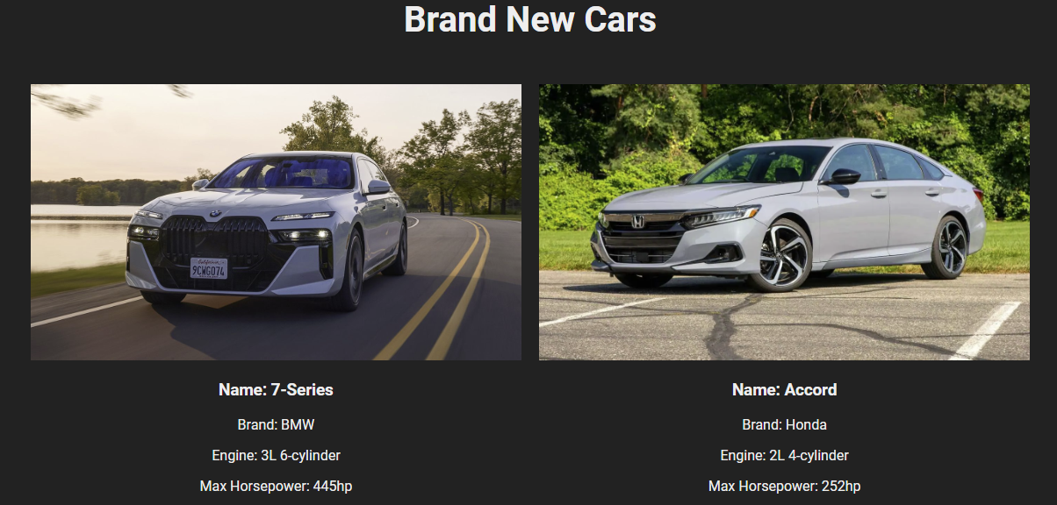

Below the Used-Car, we have Brand-New-Cars Gallery-like, it’s almost identical on how it is made.

* **Showroom Page**

This page shows a **jumbotron or an image** on the top of the page to persuade customers on visiting DiamondCut’s showrooms. This page consists of a **carousel** of the showroom’s image and a **gallery** of the showrooms.

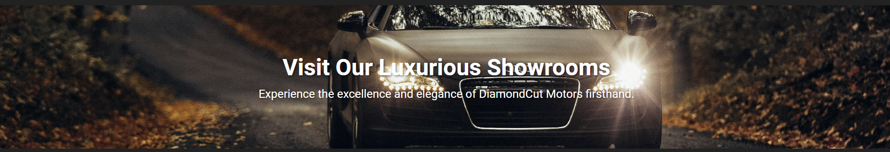

First we have an image on top of a text that persuade customers on visiting our showrooms.

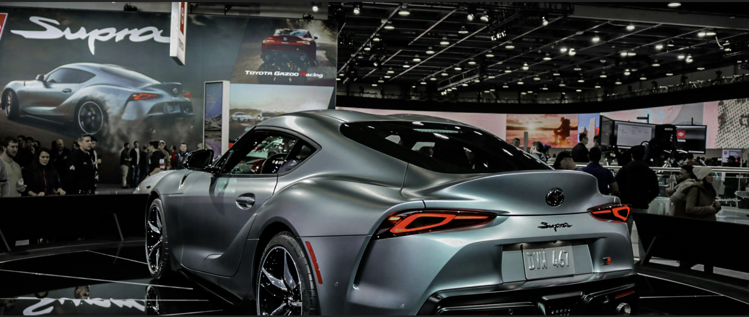

Below that, we have an auto carousel that cycles through our showroom images, it is set to every 5 seconds.

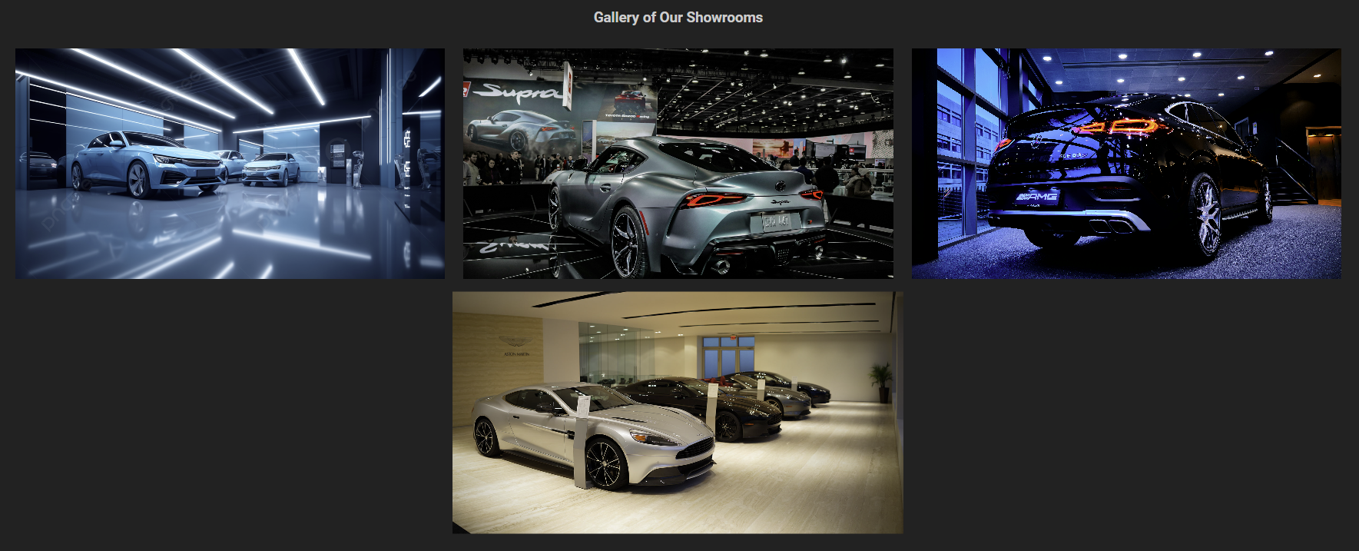

Next, we have our gallery that highlights all our showroom images. When you hover the images, it zooms a bit.

* **About Us Page**

This page provides deeper **information** about DiamondCut Motors as a synergic company. In this page, inform customers of the company’s **vision, mission,** and brief **history**. Lastly, provide the company’s **social media** links to ease customers on finding more about the company.

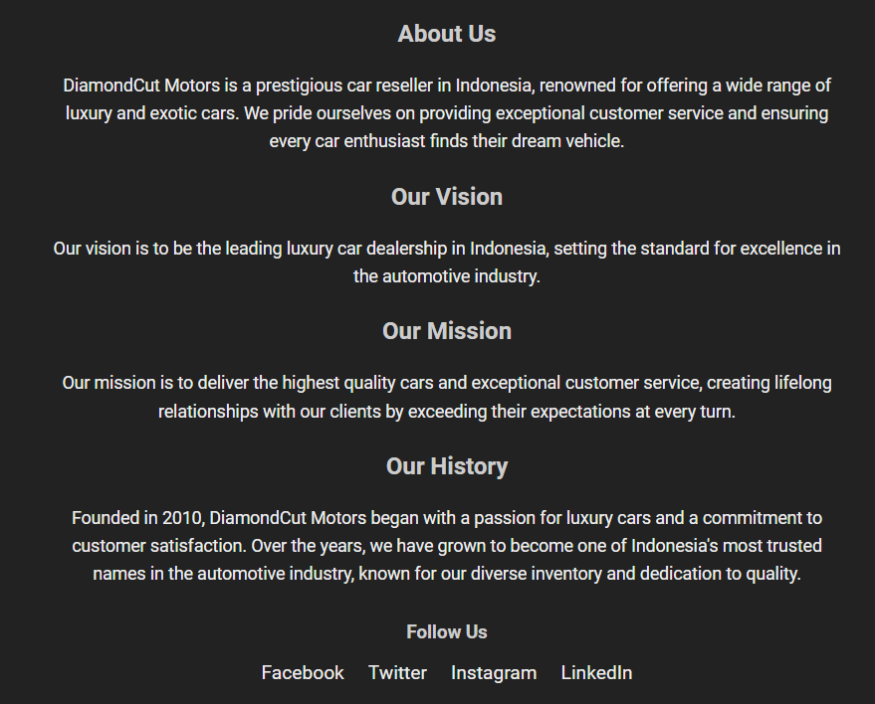

As instructed, we have information regarding our history, vision, mission, and also our social media links. The links actually go to DiamondCut Motors’s account, currently it doesn’t exist yet.



* **Login Page**

This page provides a **login** **form** for the customer. Customer needs to input several **personal information**, including username, email, phone number, password, and confirm password. The customer also must agree to the terms and services before signing in.You are asked to create **five kinds of form components** and **five kinds of validation**. For validation, you must create it using **JavaScript** and **not use regular expression**.

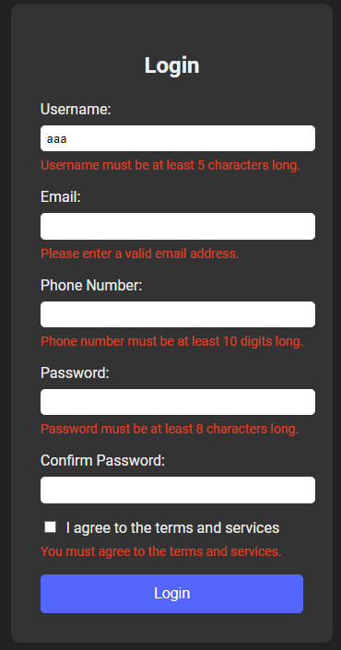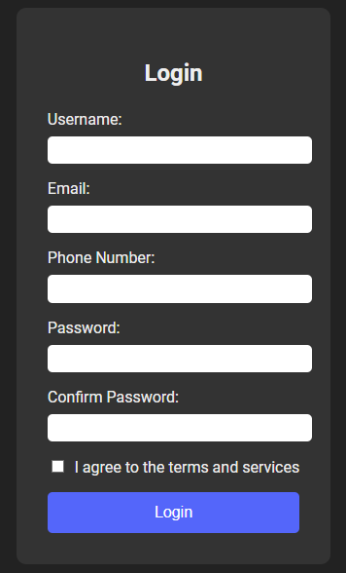 The Login page have the validations. As you can see on the right side of the page when I enter “aaa” as the username which doesn’t comply with the validation.

**REFERENCE:**

How the page looks like:

I like the dark theme of these websites. So I used them as my reference.

<https://www.ferrari.com/en-EN>

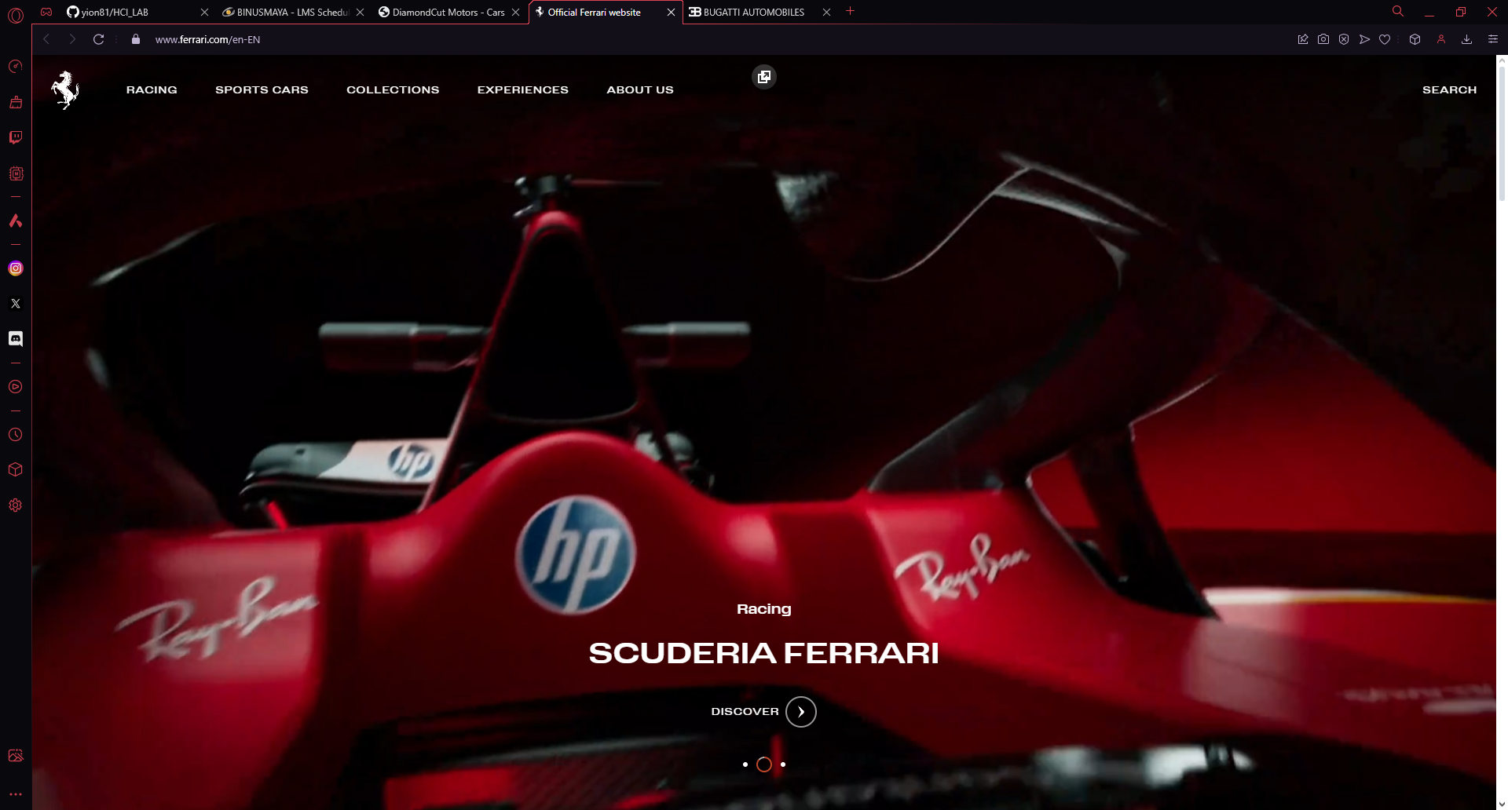

On this, I like the way it has video-carousel type.

<https://www.bugatti.com>

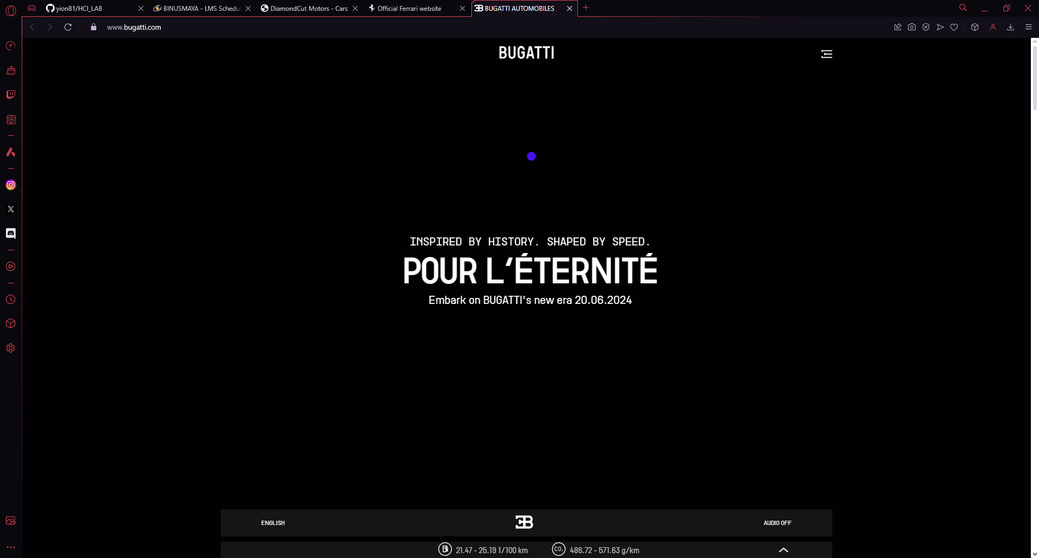

Assets Links:

<https://www.carlogos.org/car-brands/>  
<https://unsplash.com/photos/black-bmw-m-3-coupe-on-road-during-daytime-a2Qs_LkM8-8>  
<https://unsplash.com/photos/gray-coupe-on-parking-area-VsXHzSdwuik>  
<https://unsplash.com/photos/red-ferrari-458-italia-parked-beside-red-wall-dxJ80oNvnhE>  
<https://unsplash.com/photos/black-bmw-m-3-parked-on-sidewalk-during-daytime-rq-5D1S9zVc>  
<https://unsplash.com/photos/black-vehicle-on-road-between-trees-during-daytime-Yp9FdEqaCdk>  
<https://unsplash.com/photos/red-porsche-911-parked-on-road-during-night-time-pO0fX5rMzhY>  
<https://unsplash.com/photos/black-and-orange-lamborghini-aventador-GygxO4kIQhY>  
<https://unsplash.com/photos/gray-sports-coupe-parked-in-shop-ccE0sQMMl5M>  
<https://en.wikipedia.org/wiki/Ferrari_GG50>  
<https://www.caranddriver.com/bmw/7-series>  
<https://www.porsche.com/international/models/911/911-gt3-models/911-gt3/>  
<https://www.honda-indonesia.com/accord>